

Faculty of Engineering

Department of Civil Engineering

2017-2018 Spring Semester

**CE 0337 Water Resources Management**

**Reservoir Problem and CPM Problem   
Homeworks by LINDO**

Prepared By  
1600006183 Tuğçe Altınkaynak

**Dr. K. Emre Can**

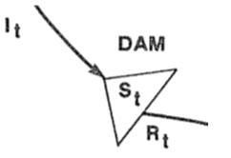**Reservoir Problem**  
The table below shows the forecasted (estimated) monthly flows in (106m3) to a systems shown on the side.   
  
  
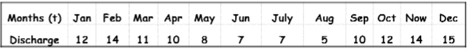

Write mathematical models that will answer the following questions and solve via LINDO.  
a) What will be the capactiy of the reservoir if the minimum required release is 9*106 m3?  
b) What is the maximum yield (RMIN) if the existing reservoir’s capacity is 10*106 m3?

**Solution:   
a)**  
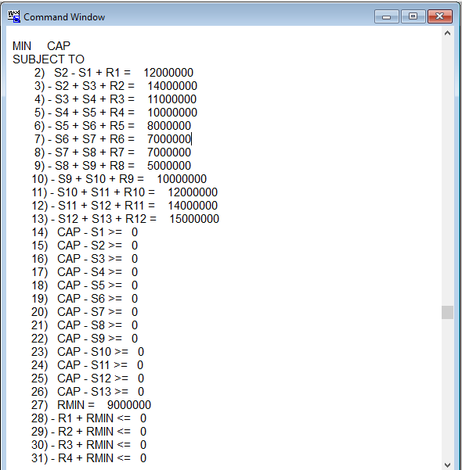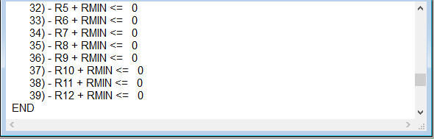

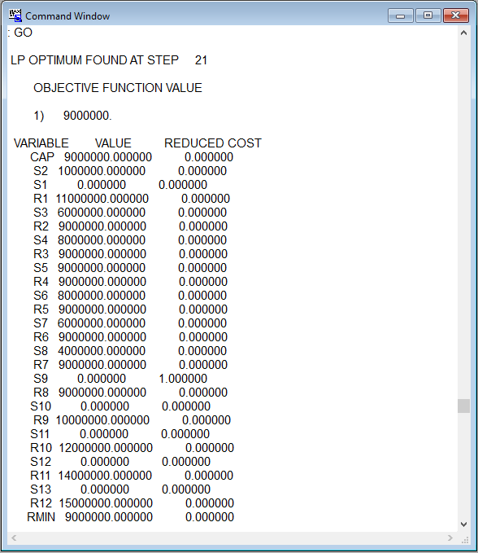

**b)**

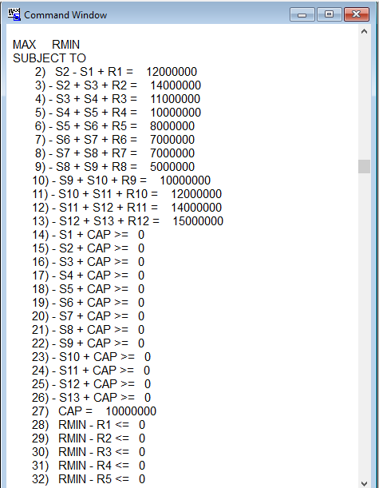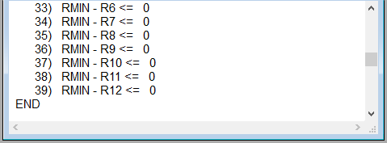

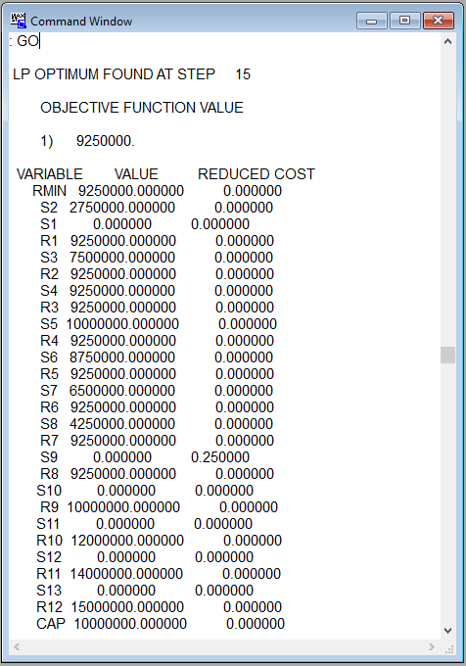

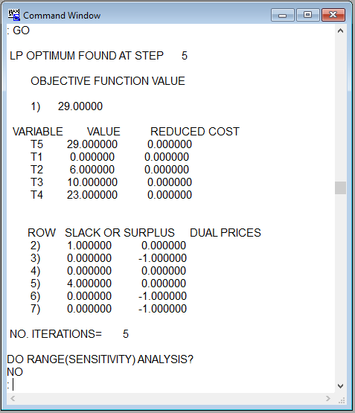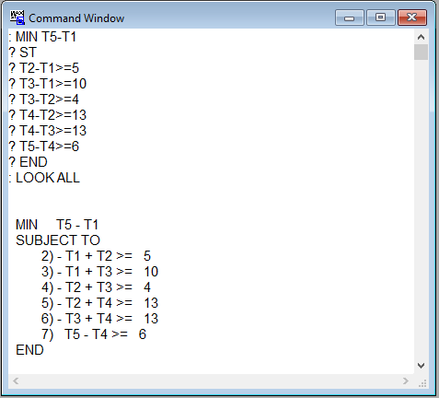**CPM Problem**   
Write a linear programming formulation to solve the following CPM problem if the numbers on the arcs indicate the project completion times.  
The objective is to determine the minimum time required to complete the project.  
Solve the problem using Lindo or another computer package and find the critical path.  
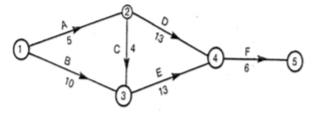  
**Solution:**

T3-T1>=10, T3-T1= 10  
 T2-T1>=5, T2-T1= 6  
 T3-T2>=4, T3-T2= 10-6= 4  
 T4-T2>=13, T4-T2= 23-6= 17  
 T4-T3>=13, T4-T3= 23-10= 13  
 T5-T4>=6, T5-T4= 29-23= 6

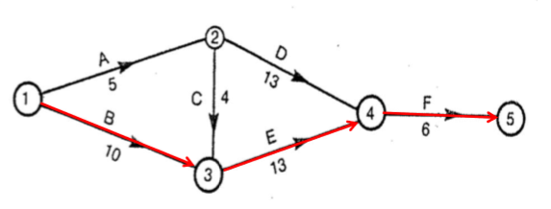

Critical Path:  
 1 🡪 3 🡪 4 🡪 5